

**BIG DATA ANALYTICS LAB**

**WEEK-10**

**NAME :** T.Sowmya **BRANCH & SEC :** CSD-A

**ROLLNO :** 22R21A6757 **DATE : 2-12-2024**

**PROBLEM STATEMENT:**

**Implement the k-means algorithm for clustering**

1. **Importing Libraries**

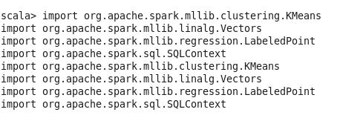

1. **Initialize SQLContext (available in Spark 1.6.0)**



1. **Sample dataset: An RDD of LabeledPoint (label, features)**

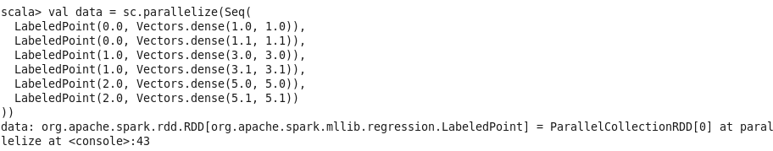

1. **Convert the data to an RDD of Vectors (KMeans expects an RDD of Vectors)**



1. **Initialize KMeans clustering**



1. **Train the model**

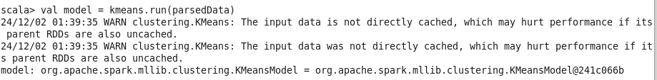

1. **Make predictions (assign each point to a cluster)**



1. **Print the predictions**

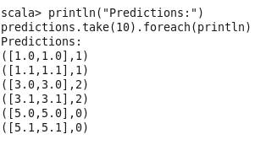

1. **Print Cluster Centers**

